**Optimization Techniques**

**NAME**: TITHI PATEL

**ENROLLMENT NUMBER: 18BECE30558**

**5 TH SEM CE SHIFT 2**

**PRACTICAL 13:** Represent Primal and Dual of one of two LPP problem given earlier in graph with manual conversion.

-----------------------------------------------------------------------------------------------------------------------------------

**Primal Problem:**

Z=(0.09*X)+(0.15*Y)

9*X+15*Y >=6000000

5*X+15*Y <=3000000

Where x,y>=0

[X,Y]=meshgrid(0:100);

>> Z=(0.09*X)+(0.15*Y);

>> contour(X,Y,Z,40);

>> hold on;

>> XX=[0:5:50];

>> YY1=f1(XX);

>> YY2=f2(XX);

>> plot(XX,XX,YY1,YY2,1,1,'033','',[2 4 8 12]);

>>title('Plotting Primal');

CODE IN f1.m:

function X=f1(Y)

X=((6000000-15*Y)/9);

endfunction

CODE IN f2.m:

function X=f2(Y)

X=((3000000-8*Y)/5);

endfunction

OUTPUT:

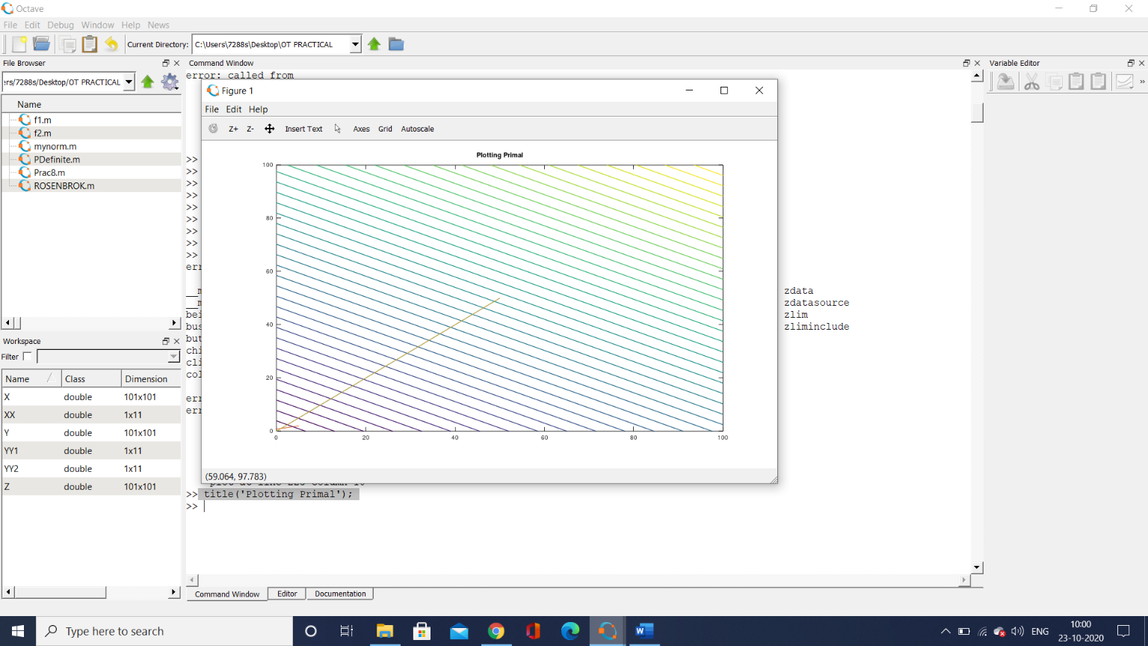

--------------------------------------------------------------------------------------------

**Dual Problem:**

Z=(0.09*X)+(0.15*Y)

9*X+15*Y >=6000000

5*X+15*Y <=3000000

Where x,y>=0

[X,Y]=meshgrid(0:100);

>> Z=(0.09*X)+(0.15*Y);

>> contour(X,Y,Z,40);

>> hold on;

>> XX=[0:5:50];

>> YY1=f1(XX);

>> YY2=f2(XX);

>> plot(XX,XX,YY1,YY2,1,1,'035','',[2 4 8 12]);

>>title('Plotting Dual');

CODE IN fd1.m:

function X=fd1(Y)

X=((6000000-9*Y)/15);

endfunction

CODE IN fd2.m:

function X=fd2(Y)

X=((3000000-5*Y)/8);

endfunction

OUTPUT:

